ASSIGNMENT 4

Ultrasonic sensor simulation in Wokwi

|  |  |
| --- | --- |
| Date | 25 October 2022 |
| Student Name | NANDAMUDI DINESH |
| Student Roll Number | 610519104067 |
| Maximum Marks | 2 Marks |

**Question-1:**

Write a code and connections in wokwi for the ultrasonic sensor. Whenever the distance is less than 100cms send an “Alert” to IBM cloud and display in the device recent events.

# Code:

#include <WiFi.h> #include <PubSubClient.h>

void callback(char* subscribetopic, byte* payload, unsigned int payloadLength);

//-------credentials of IBM Accounts------

#define ORG "kotoq5"//IBM ORGANITION ID

#define DEVICE_TYPE "ESP32"//Device type mentioned in ibm watson IOT Platform #define DEVICE_ID "12345"//Device ID mentioned in ibm watson IOT Platform #define TOKEN "12345678" //Token

String data3;

char server[] = ORG ".messaging.internetofthings.ibmcloud.com"; char publishTopic[] = "iot-2/evt/Data/fmt/json";

char subscribetopic[] = "iot-2/cmd/test/fmt/String"; char authMethod[] = "use-token-auth";

char token[] = TOKEN;

char clientId[] = "d:" ORG ":" DEVICE_TYPE ":" DEVICE_ID;

WiFiClient wifiClient;

PubSubClient client(server, 1883, callback ,wifiClient); const int trigPin = 5;

const int echoPin = 18; #define SOUND_SPEED 0.034 long duration;

float distance; void setup() {

**Serial**.begin(115200); pinMode(trigPin, OUTPUT); pinMode(echoPin, INPUT); wificonnect(); mqttconnect();

}

void loop()

{

digitalWrite(trigPin, LOW); delayMicroseconds(2); digitalWrite(trigPin, HIGH); delayMicroseconds(10); digitalWrite(trigPin, LOW); duration = pulseIn(echoPin, HIGH);

distance = duration * SOUND_SPEED/2; **Serial**.print("Distance (cm): "); **Serial**.println(distance); if(distance<100)

{

**Serial**.println("ALERT!!"); delay(1000);

PublishData(distance); delay(1000);

if (!client.loop()) { mqttconnect();

}

}

delay(1000);

}

void PublishData(float dist) { mqttconnect();

String payload = "{\"Distance\":"; payload += dist;

payload += ",\"ALERT!!\":""\"Distance less than 100cms\""; payload += "}";

**Serial**.print("Sending payload: ");

**Serial**.println(payload);

if (client.publish(publishTopic, (char*) payload.c_str())) {

**Serial**.println("Publish ok");

} else {

**Serial**.println("Publish failed");

}

}

void mqttconnect() {

if (!client.connected()) { **Serial**.print("Reconnecting client to "); **Serial**.println(server);

while (!!!client.connect(clientId, authMethod, token)) {

**Serial**.print("."); delay(500);

}

initManagedDevice();

**Serial**.println();

}

}

void wificonnect()

{

**Serial**.println(); **Serial**.print("Connecting to "); WiFi.begin("Wokwi-GUEST", "", 6); while (WiFi.status() != WL_CONNECTED) { delay(500);

**Serial**.print(".");

}

**Serial**.println(""); **Serial**.println("WiFi connected"); **Serial**.println("IP address: "); **Serial**.println(WiFi.localIP());

}

void initManagedDevice() {

if (client.subscribe(subscribetopic)) { **Serial**.println((subscribetopic)); **Serial**.println("subscribe to cmd OK");

} else {

**Serial**.println("subscribe to cmd FAILED");

}

}

void callback(char* subscribetopic, byte* payload, unsigned int payloadLength)

{

**Serial**.print("callback invoked for topic: ");

**Serial**.println(subscribetopic);

for (int i = 0; i < payloadLength; i++) {

//Serial.print((char)payload[i]); data3 += (char)payload[i];

}

**Serial**.println("data: "+ data3); data3="";

}

# Diagram.json:

{

"version": 1, "author": "Nandamudi Dinesh",

"editor": "wokwi", "parts": [

{ "type": "wokwi-esp32-devkit-v1", "id": "esp", "top": -4.67, "left": -114.67, "attrs": {} },

{ "type": "wokwi-hc-sr04", "id": "ultrasonic1", "top": 15.96, "left": 89.17, "attrs": {} }

],

"connections": [

[ "esp:TX0", "$serialMonitor:RX", "", [] ],

[ "esp:RX0", "$serialMonitor:TX", "", [] ], [

"esp:VIN", "ultrasonic1:VCC", "red",

[ "h-37.16", "v-178.79", "h200", "v173.33", "h100.67" ]

],

[ "esp:GND.1", "ultrasonic1:GND", "black", [ "h39.87", "v44.04", "h170" ] ],

[ "esp:D5", "ultrasonic1:TRIG", "green", [ "h54.54", "v85.07", "h130.67" ] ],

[ "esp:D18", "ultrasonic1:ECHO", "green", [ "h77.87", "v80.01", "h110" ] ]

]

}

# Circuit Diagram:

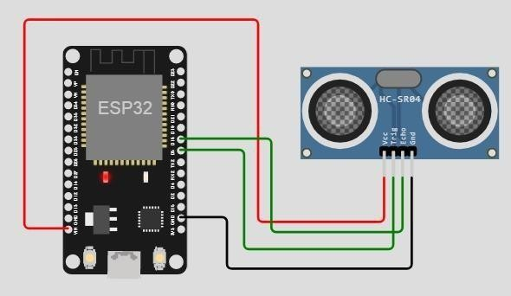

**Output:**

Wokwi output:

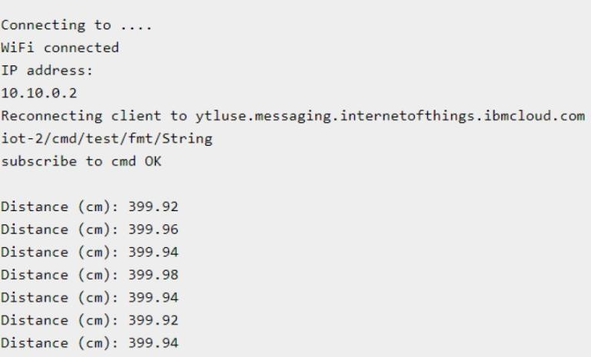

# IBM cloud output:

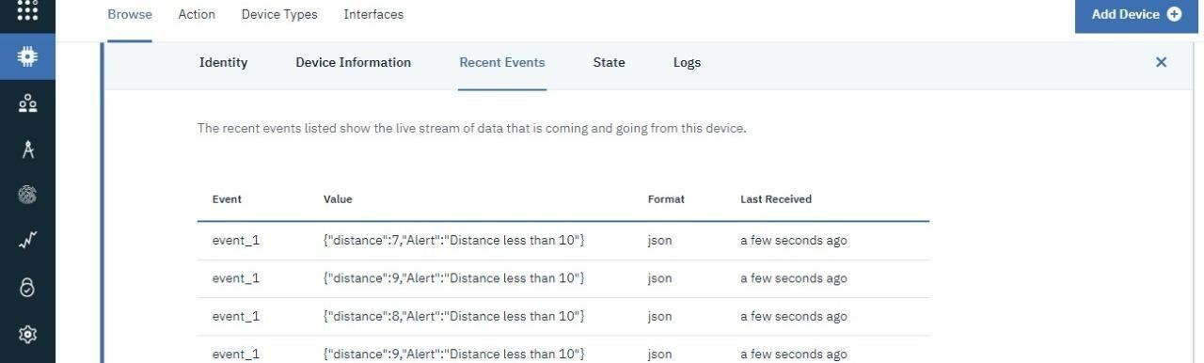

**Wokwi simulation link:**

**https://wokwi.com/projects/347461882561430100**